# **FROM 28th August TO 3rd September**

# **Project ID:**

# **2021J_BV01_BCI Browser**

# **Project Title:**

# **Design and development of Brain Computer Interface Browser on Web and Mobile**

# **Summary:**

* NodeJS+MySQL database connection
* Visualization of data

# **Detail:**

**NodeJS+MySQL Connection**

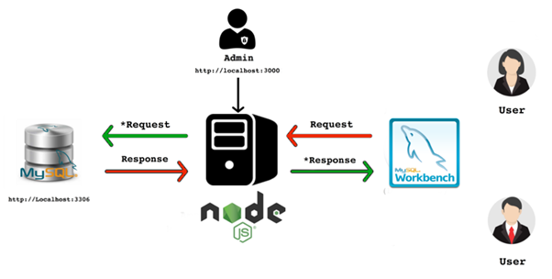

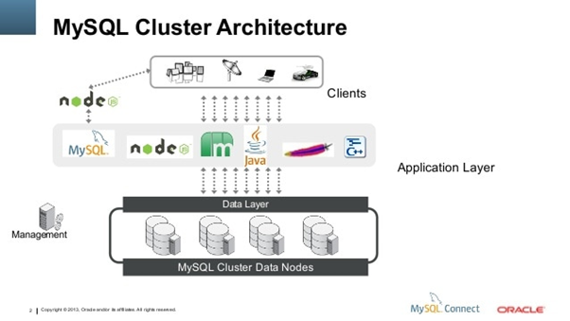

const express = require('express')

const bodyParser = require('body-parser')

const mysql = require('mysql')

const app = express()

const port = process.env.PORT||5000;

// parse application/x-www-form-urlencoded

app.use(bodyParser.urlencoded({ extended: false }))

// parse application/json

app.use(bodyParser.json())

// MySQL

const pool = mysql.createPool({

host : 'localhost',

user : 'root',

password : '',

database : 'demo'

})

app.get('', (req, res) => {

pool.getConnection((err, connection) => {

if(err) throw err

console.log('connected as id ' + connection.threadId)

connection.query('SELECT * from contactdetails', (err, rows) => {

connection.release() // return the connection to pool

if (!err) {

res.send(rows)

} else {

console.log(err)

}

// if(err) throw err

console.log('The data from contactdetails table are: \n', rows)

})

})

})

app.get('/:id', (req, res) => {

pool.getConnection((err, connection) => {

if(err) throw err

connection.query('SELECT * FROM contactdetails WHERE id = ?', [req.params.id], (err, rows) => {

connection.release() // return the connection to pool

if (!err) {

res.send(rows)

} else {

console.log(err)

}

console.log('The data from contactdetails table are: \n', rows)

})

})

});

app.delete('/:id', (req, res) => {

pool.getConnection((err, connection) => {

if(err) throw err

connection.query('DELETE FROM contactdetails WHERE id = ?', [req.params.id], (err, rows) => {

connection.release() // return the connection to pool

if (!err) {

res.send(`person with the record ID ${[req.params.id]} has been removed.`)

} else {

console.log(err)

}

console.log('The data from contactdetails table are: \n', rows)

})

})

});

app.post('', (req, res) => {

pool.getConnection((err, connection) => {

if(err) throw err

const params = req.body

connection.query('INSERT INTO contactdetails SET ?', params, (err, rows) => {

connection.release() // return the connection to pool

if (!err) {

res.send(`person with the record ID has been added.`)

} else {

console.log(err)

}

console.log('The data from contactdetails table are: \n', rows)

})

})

});

app.put('', (req, res) => {

pool.getConnection((err, connection) => {

if(err) throw err

console.log(`connected as id ${connection.threadId}`)

const { id, name, tagline, description, image } = req.body

connection.query('UPDATE contactdetails SET name = ?, tagline = ?, description = ?, image = ? WHERE id = ?', [name, tagline, description, image, id] , (err, rows) => {

connection.release() // return the connection to pool

if(!err) {

res.send(`person with the name: ${name} has been added.`)

} else {

console.log(err)

}

})

console.log(req.body)

})

})

// Listen on environment port or 5000

app.listen(port, () => console.log(`Listening on port ${port}`))

LOGIN AND REGISTRATION PAGE

